Software Design Document
Detecting Learning Communities Using Graph Algorithms in R



Submitted by
Fahad Abbas (F22BINFT1E02120)

Submitted to
Dr. Mustafa Hameed

Department of Information Technology
Faculty of Computing
The Islamia University of Bahawalpur

EXECUTIVE SUMMARY

Detecting Learning Communities Using Graph Algorithms in R is a web-based analytical platform designed to detect, visualize, and analyze learning communities within educational networks. The system enables researchers and educators to upload network data, apply multiple community detection algorithms, and generate comprehensive statistical analyses with interactive visualizations.
Key Objectives
- Provide intuitive interface for network data analysis
- Implement 6 state-of-the-art community detection algorithms
- Enable real-time interactive visualization of network structures
- Generate comparative performance metrics across algorithms
- Support data export in multiple formats
Target Users
- Educational researchers
- Network analysts
- Academic administrators
- Data scientists

Table of Contents
EXECUTIVE SUMMARY 2
1. SYSTEM OVERVIEW 4
1.1 System Context Diagram 4
1.2 High-Level Feature Set 5
2 APPLICATION ARCHITECTURE 6
2.1 Architectural Overview 6
2.2 Component Interaction Diagram 7
2.3 Module Specifications 7
2.3.1 Data Upload Module 7
2.3.2 Graph Visualization Module 7
2.3.3 Community Detection Module 8
2.3.4 Metrics Calculation Module 8
2.3.5 Export Module 8
3. DATA MODEL & SCHEMA 9
3.1 Input Data Schema 9
3.1.1 CSV Edge List Format 9
3.1.2 Sample Datasets 9
3.2 Internal Data Structures 9
3.2.1 Graph Object Structure (igraph) 9
3.2.2 Community Detection Result Structure 10
3.2.3 Metrics Data Structure 11
3.3 Data Flow Diagram 12
3.4 Algorithm Comparison Data Schema 12
4. USER INTERFACE DESIGN 13
4.1 UI Architecture Overview 13
4.2 Tab-by-Tab UI Specifications 13
4.2.1 Home Tab 13
4.2.2 Data Upload Tab 14
4.2.3 Network Visualization Tab 14
5. INTEGRATION DESIGN 15
5.1 Shiny Reactive Flow 15
6. SECURITY & PERFORMANCE 15
6.1 Security Considerations 15
6.2 Performance Optimization 16
7. DEPLOYMENT ARCHITECTURE 16
7.1. Deployment Environment 16
7.2 System Requirements 17
8. TESTING STRATEGY 17
8.1 Testing 17
8.2 Risk Assessment 17
9. GLOSSARY 18
APPENDIX 19

1. SYSTEM OVERVIEW

1.1 System Context Diagram

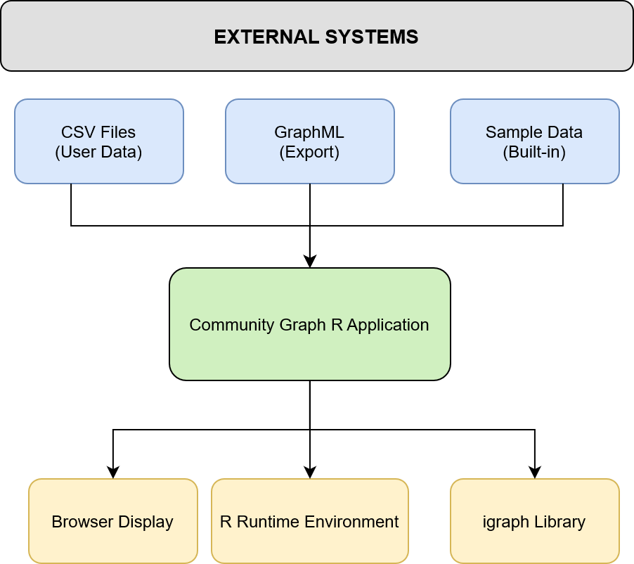

Figure 1.1: System Context Diagram

1.2 High-Level Feature Set

Feature Category | Capabilities
Data Management | CSV upload, sample datasets, graph creation, data preview
Visualization | Interactive network graphs, community coloring, physics simulation
Analysis | 6 detection algorithms, comparative metrics, statistical analysis
Metrics | Modularity, centrality, clustering coefficient, conductance
Export | CSV, GraphML, TXT reports, statistical summaries

2 APPLICATION ARCHITECTURE

2.1 Architectural Overview

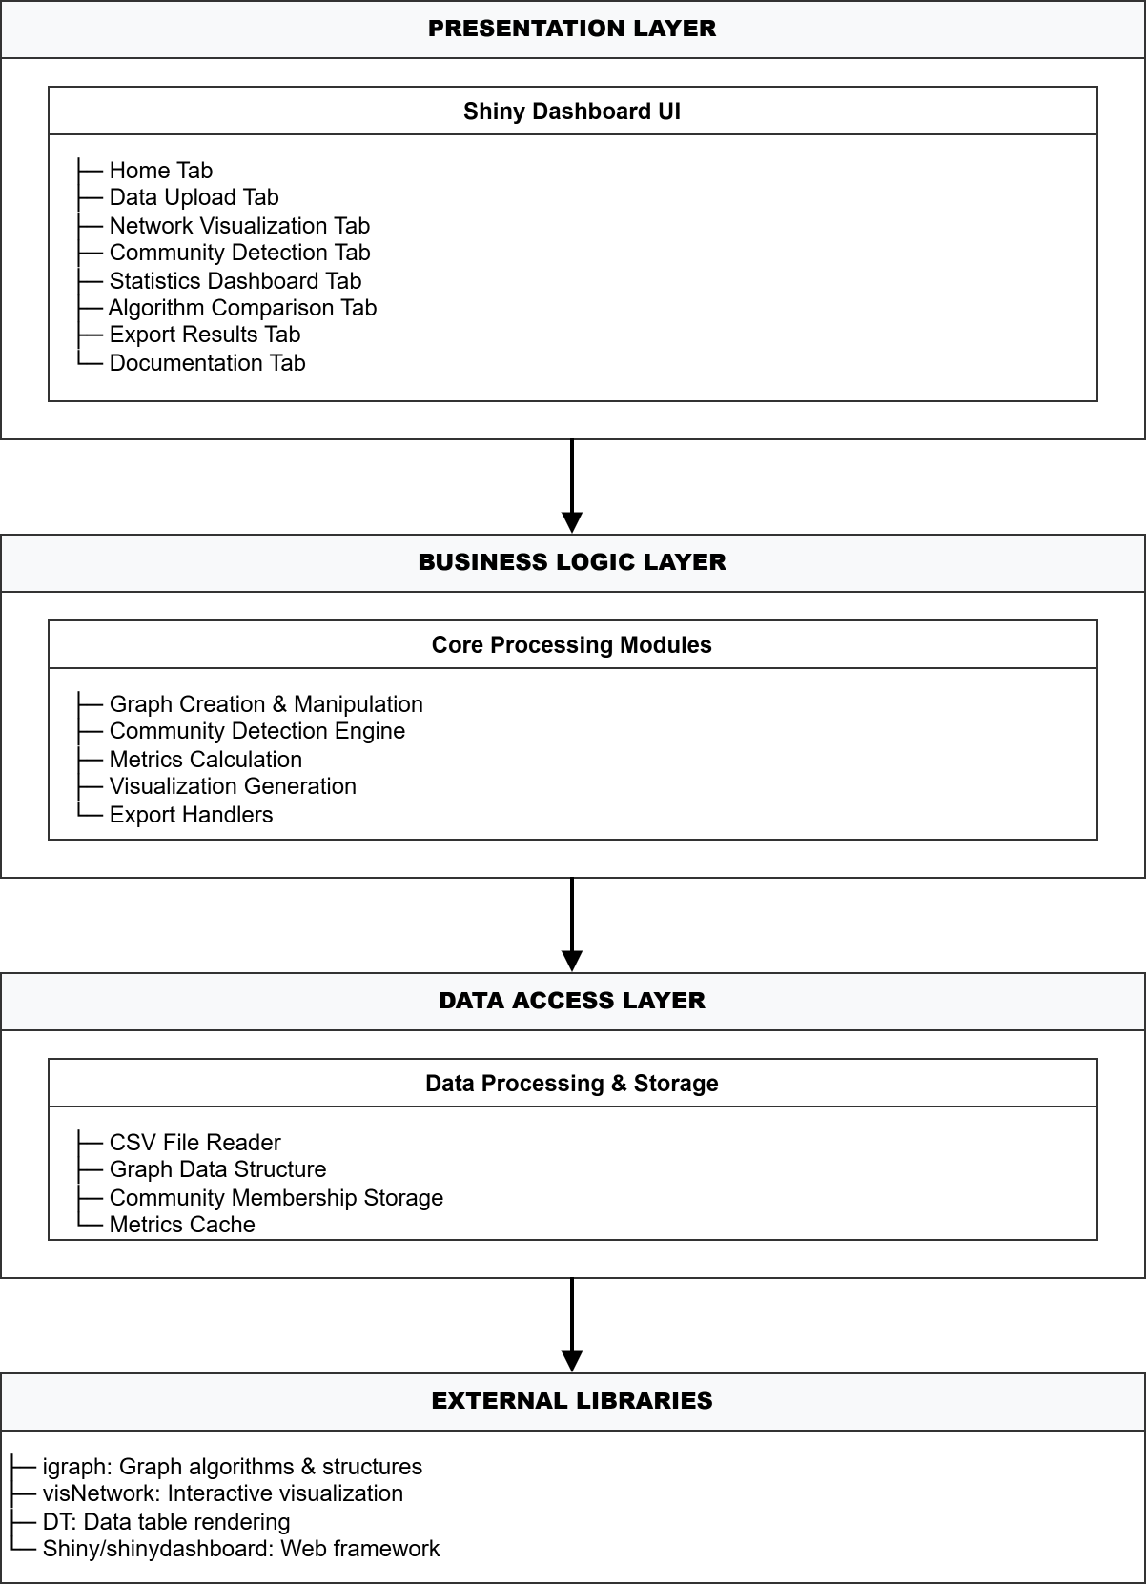
Figure 2.1: Application Architecture Diagram

2.2 Component Interaction Diagram

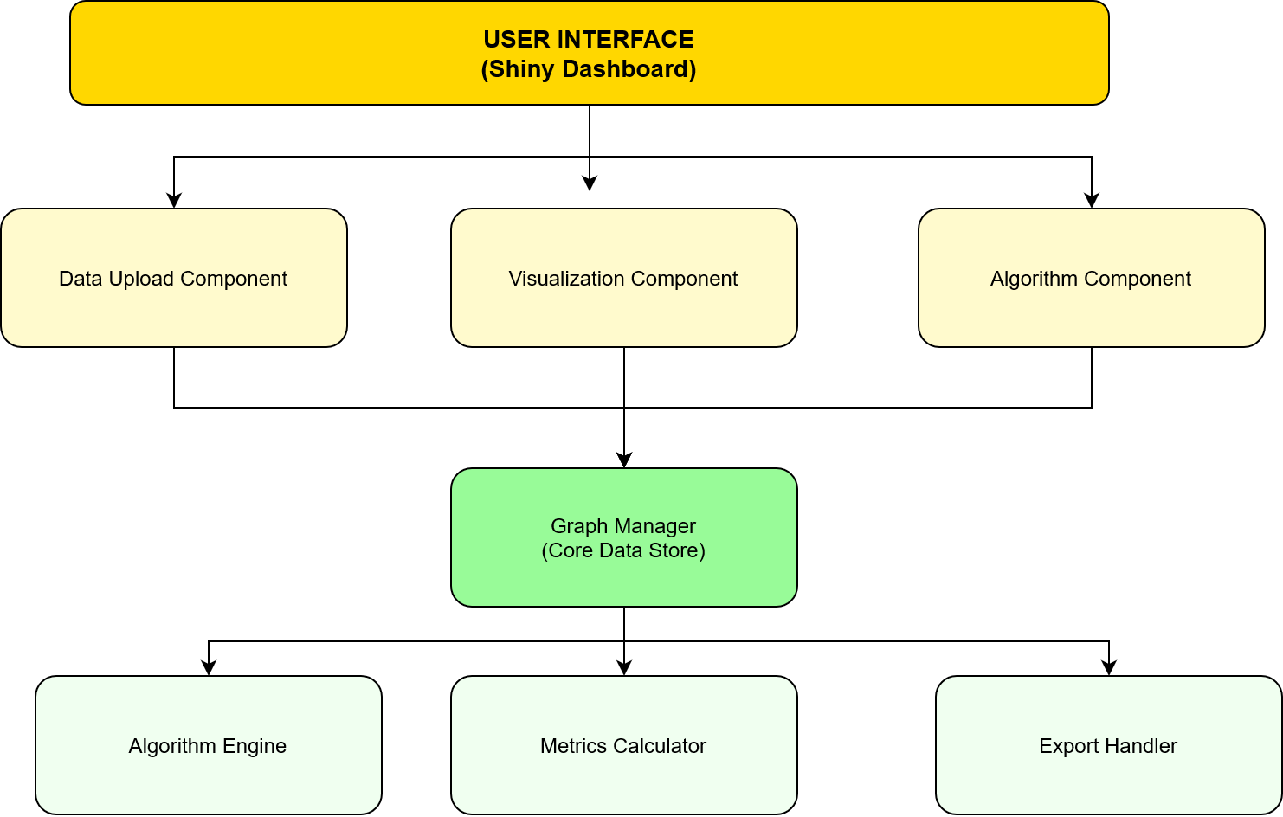
Figure 2.2: Component Interaction Diagram

2.3 Module Specifications

2.3.1 Data Upload Module

Aspect | Specification
Input Formats | CSV files with edge lists
Configuration | Graph type (directed/undirected), weighted/unweighted
Validation | Minimum 2 columns, numeric weight validation
Output | igraph object, data preview table
Error Handling | File format validation, missing data handling

2.3.2 Graph Visualization Module

Aspect | Specification
Library | visNetwork (R wrapper for vis.js)
Features | Zoom, pan, physics simulation, hover tooltips
Customization | Node size, edge width, label visibility
Performance | Optimized for graphs up to 5000 nodes
Interactivity | Node selection, edge highlighting, dynamic layout

2.3.3 Community Detection Module

Aspect | Specification
Algorithms | Louvain, Walktrap, Edge Betweenness, Label Propagation, Fast Greedy, Infomap
Input | igraph object, algorithm parameters
Output | Community membership vector, modularity score
Execution | Sequential processing with progress indication
Error Handling | Algorithm-specific error catching and reporting

2.3.4 Metrics Calculation Module

Aspect | Specification
Metrics | Modularity, density, centrality measures, clustering coefficient
Computation | Real-time calculation on demand
Caching | Results cached during session
Performance | Optimized for large networks

2.3.5 Export Module

Aspect | Specification
Formats | CSV (communities), GraphML (graph), TXT (report), CSV (statistics)
Content | Community assignments, network structure, analysis results
Naming | Timestamped filenames for traceability
Validation | Data completeness check before export

3. DATA MODEL & SCHEMA

3.1 Input Data Schema

3.1.1 CSV Edge List Format
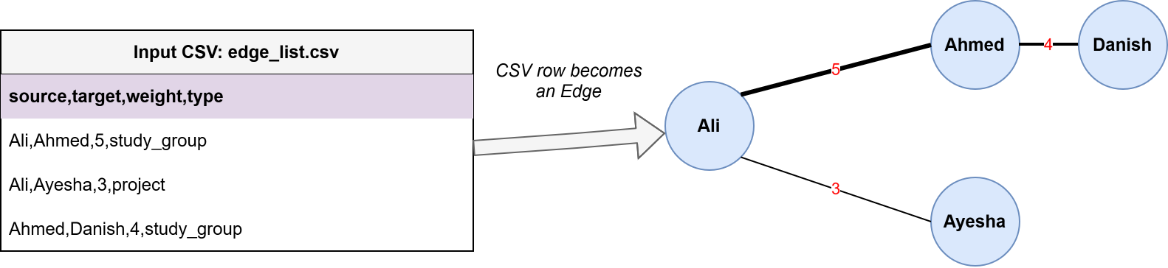
Figure 3.1.1: Structure of CSV Edge

3.1.2 Sample Datasets
Dataset | Nodes | Edges | Domain | Use Case
Student Interactions | 8-10 | 35+ | Education | Learning community detection
Course Enrollments | 15+ | 40+ | Education | Course network analysis
Forum Participation | 12+ | 30+ | Education | Discussion community analysis

3.2 Internal Data Structures

3.2.1 Graph Object Structure (igraph)

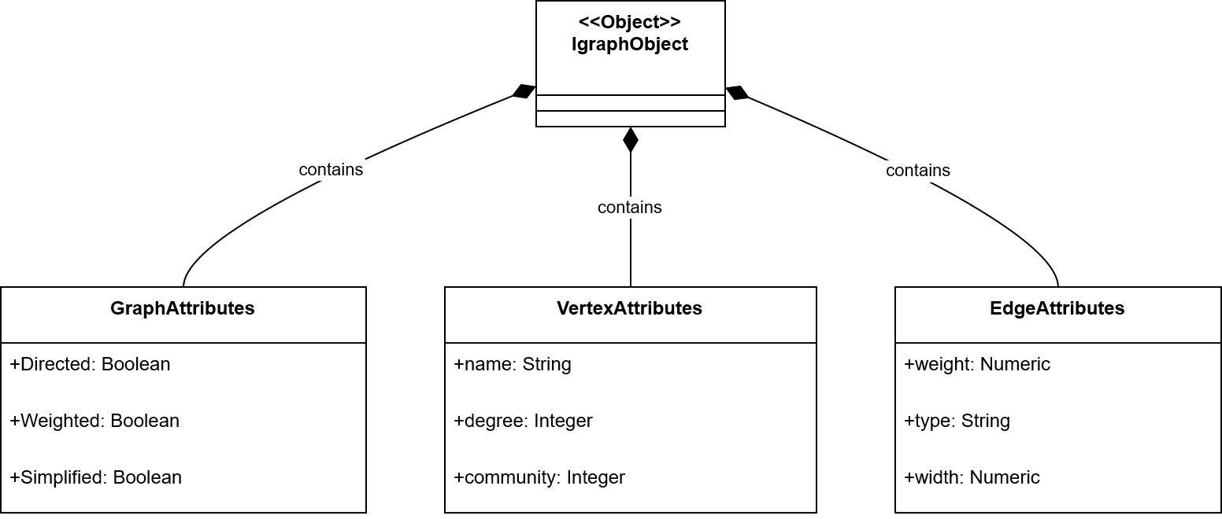
Figure 3.1.1: Graph Object

3.2.2 Community Detection Result Structure
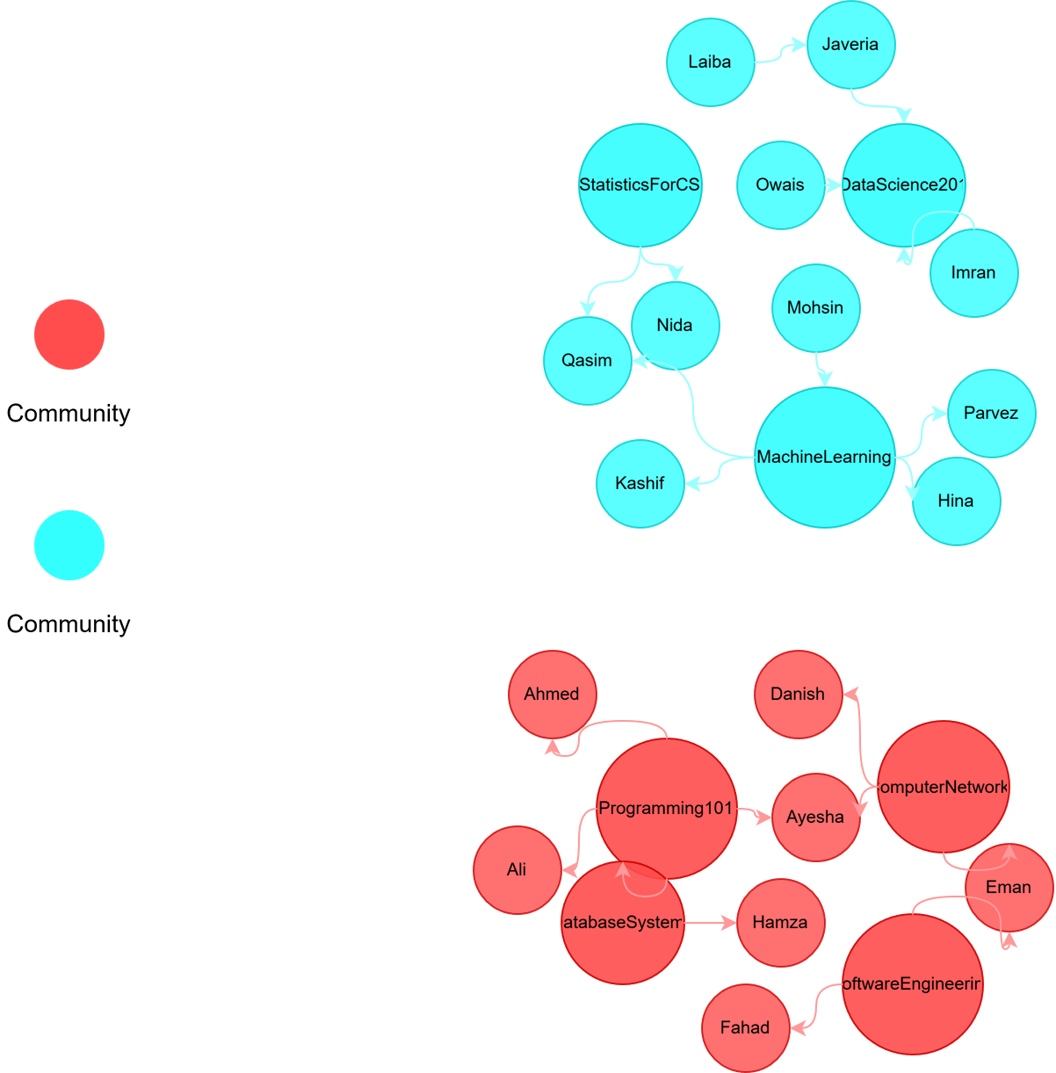

Figure 3.2.2 Community Detection Structure

3.2.3 Metrics Data Structure

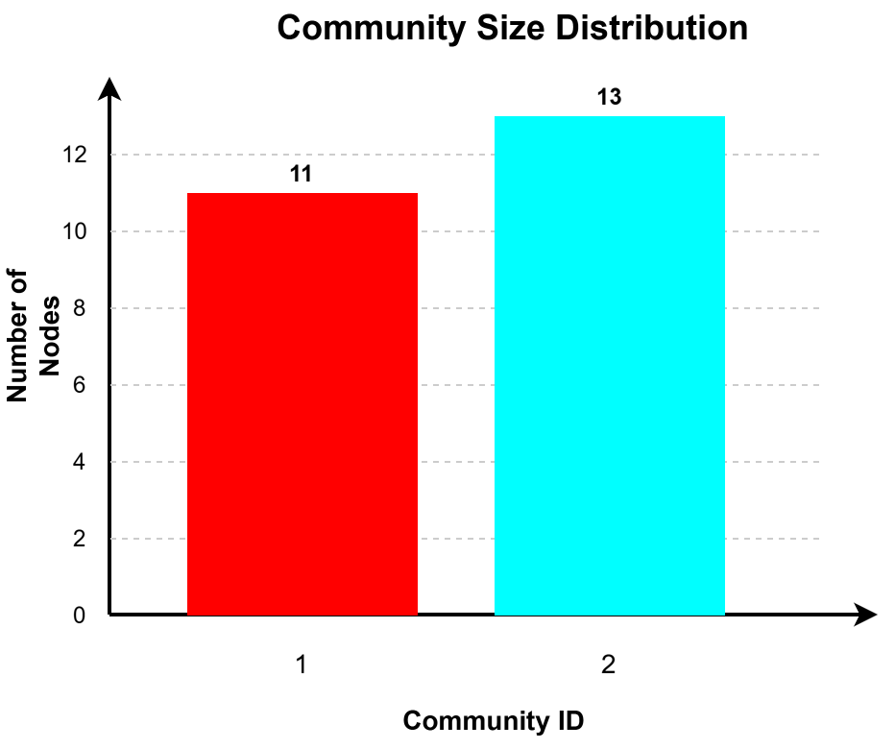
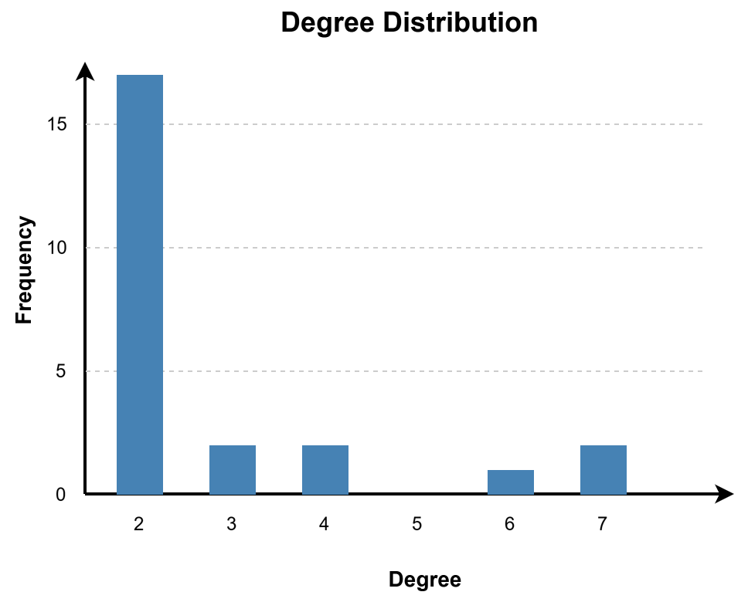
Figure 3.2.3 Metrics Data Structure

3.3 Data Flow Diagram
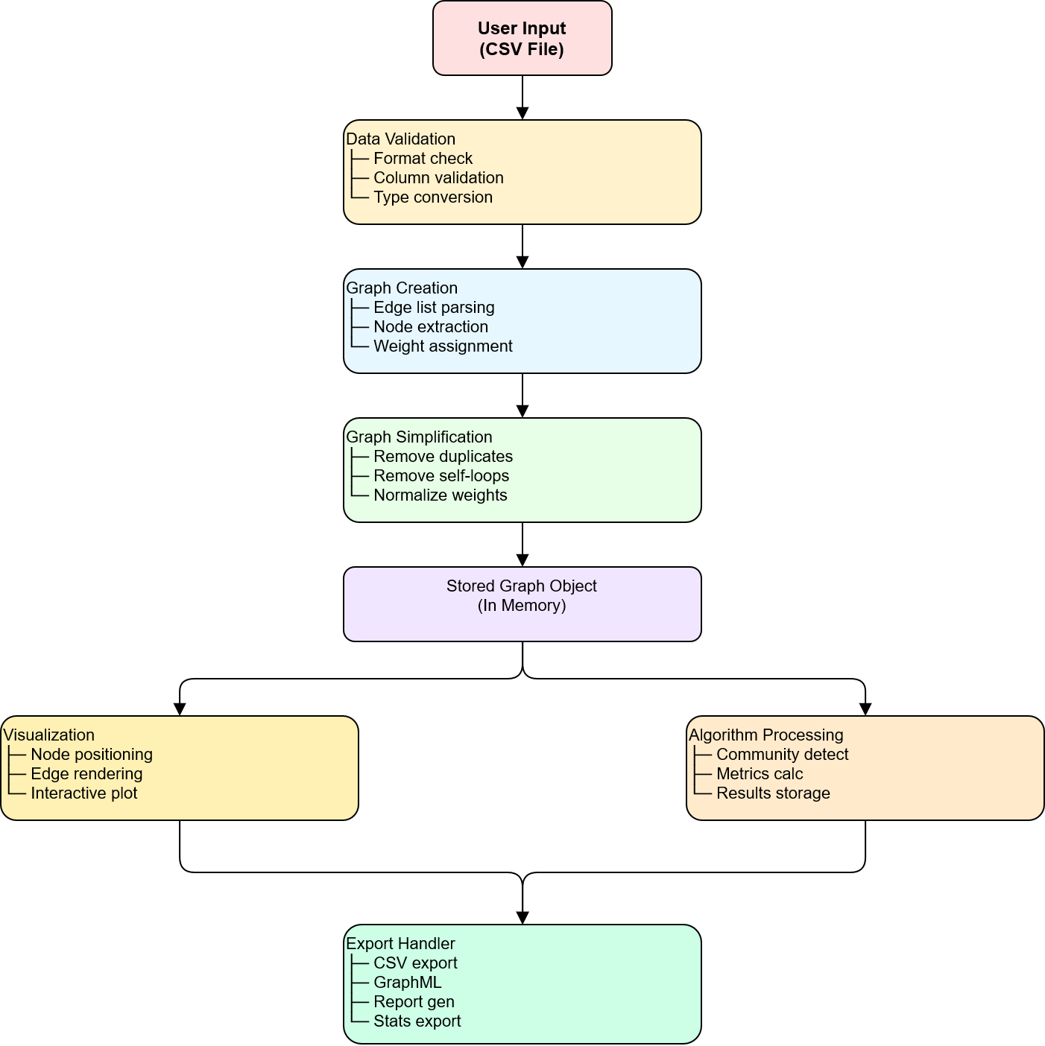
Figure 3.1: Data Flow Diagram

3.4 Algorithm Comparison Data Schema
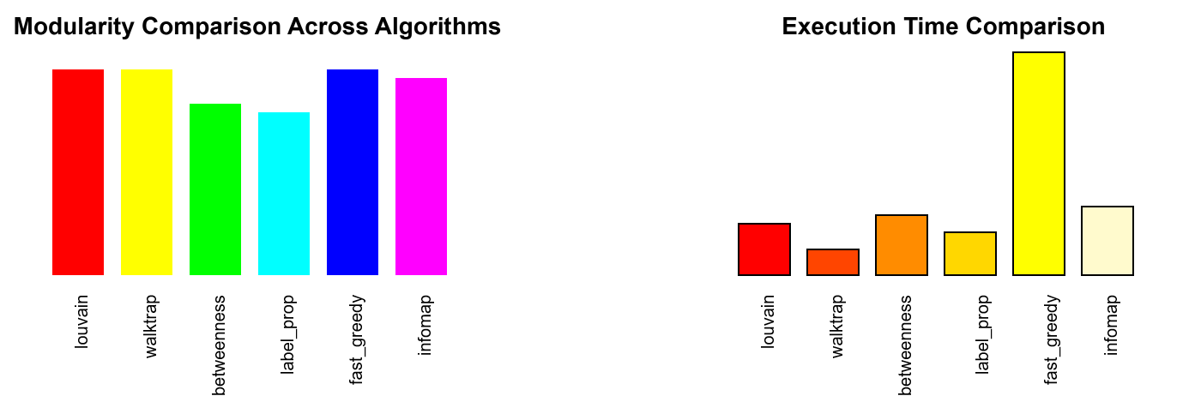
Figure 3.4: Algorithm Comparison diagram

4. USER INTERFACE DESIGN

4.1 UI Architecture Overview
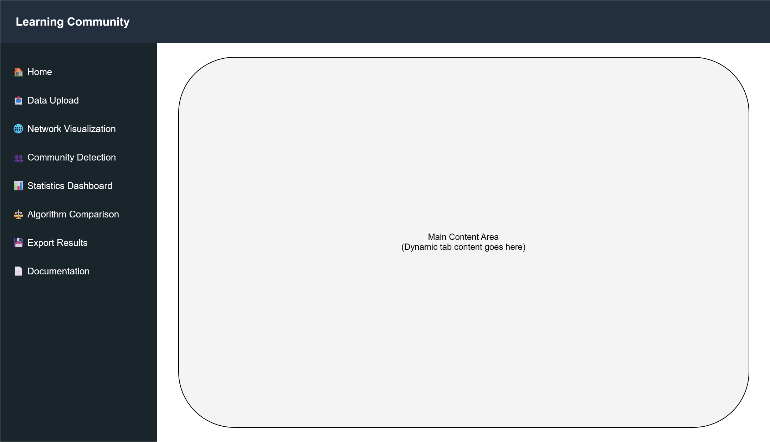
Figure 4.1 UI Architecture

4.2 Tab-by-Tab UI Specifications

4.2.1 Home Tab
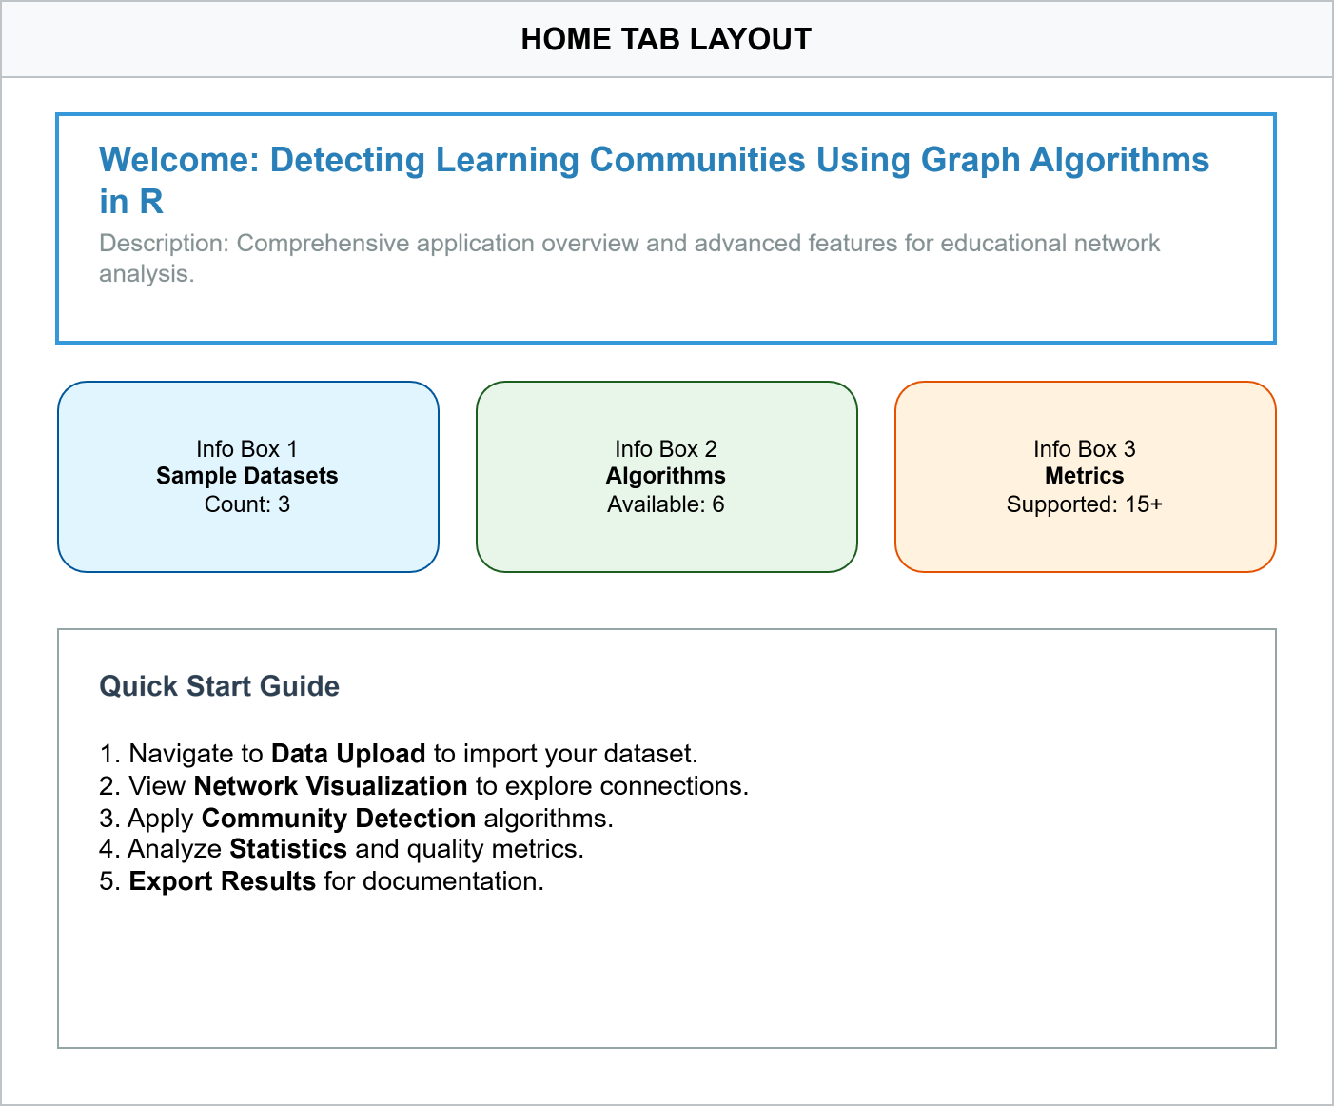
Figure 4.2.1 Home Tab

4.2.2 Data Upload Tab
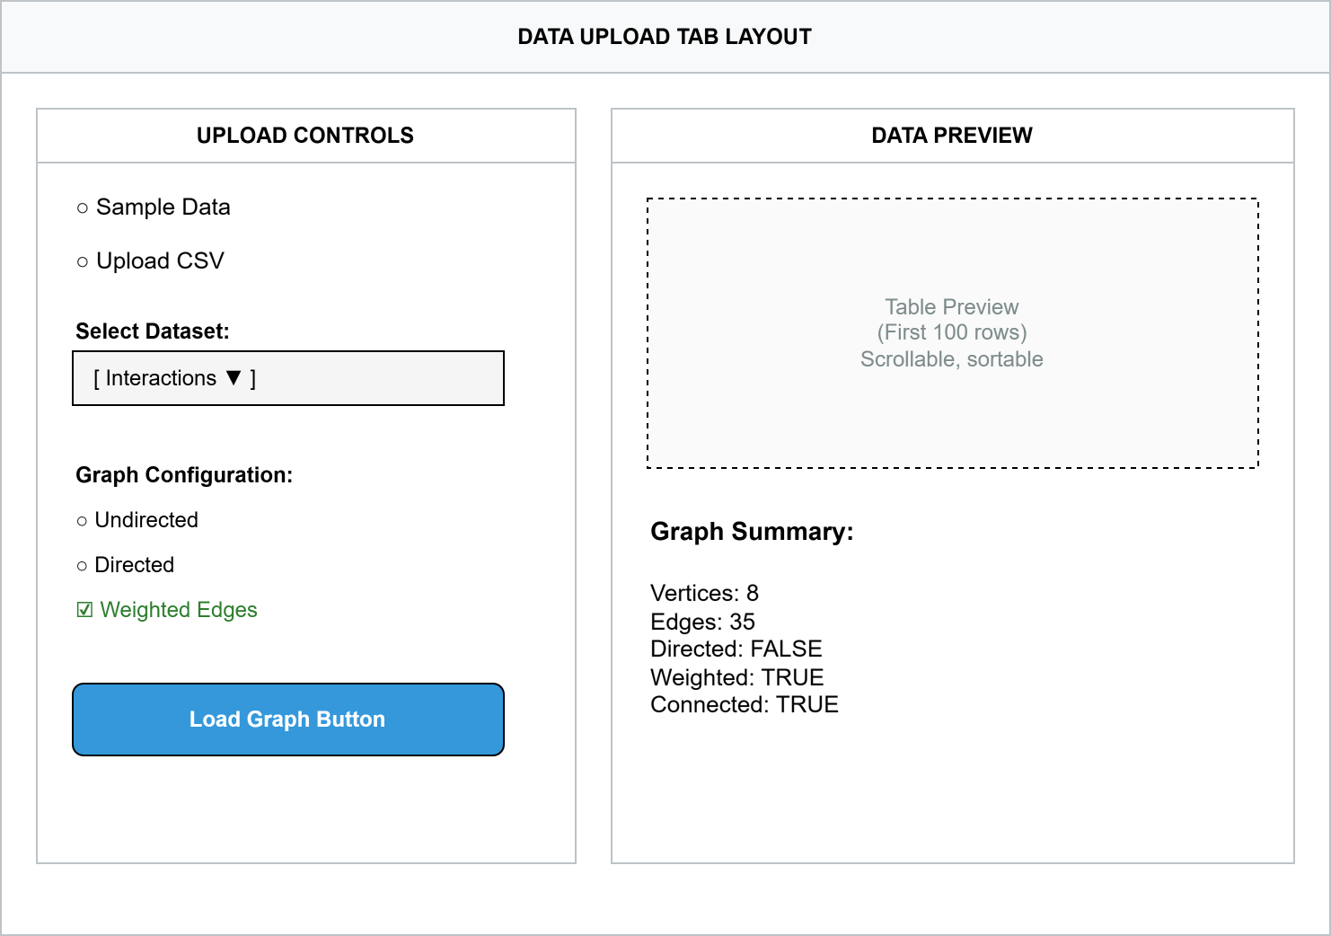
Figure 4.2.2 Data Upload Tab

4.2.3 Network Visualization Tab
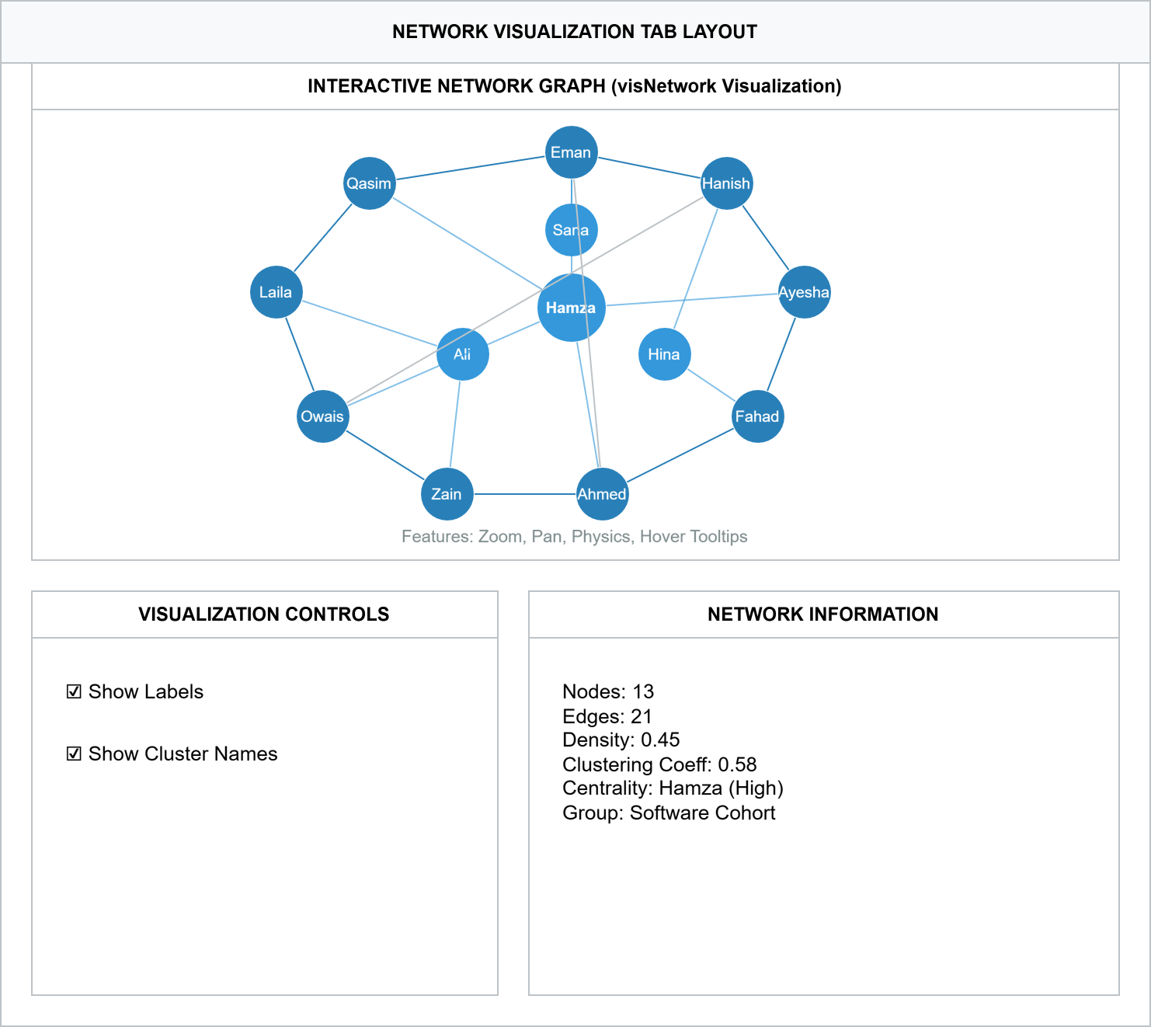
Figure 4.2.3 Network Visualization Tab

5. INTEGRATION DESIGN

5.1 Shiny Reactive Flow
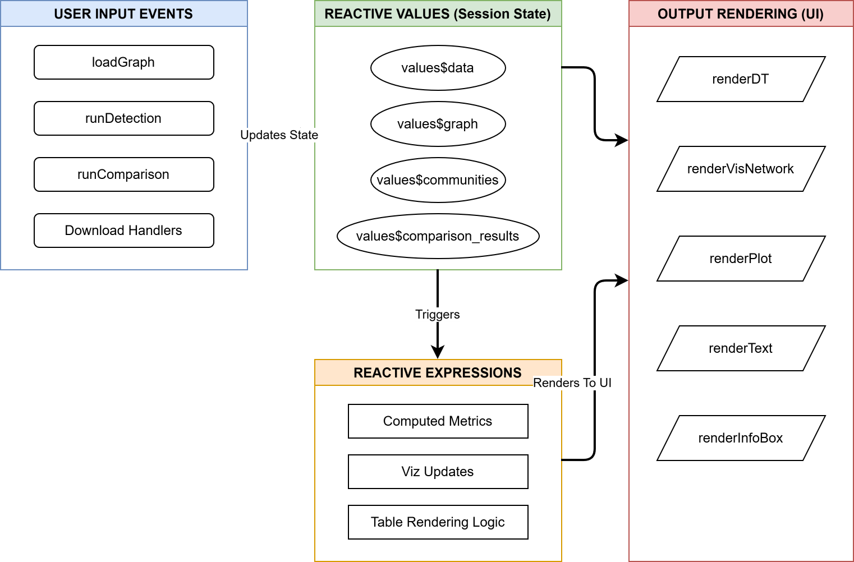
Figure 5.1: Shiny Reactive Flow Diagram

6. SECURITY & PERFORMANCE

6.1 Security Considerations

Aspect | Measure | Implementation
Input Validation | File format checking | CSV extension and structure validation
Data Sanitization | Node/edge name cleaning | Remove special characters, limit length
Session Management | User isolation | Each session has independent reactive values
File Upload | Size limits | Maximum file size enforcement
Error Handling | Safe error messages | No sensitive information in error output

6.2 Performance Optimization
Category | Strategies
Graph Processing | Simplify graphs (remove duplicates/self-loops)Cache graph objects in reactive valuesLazy evaluation of metrics
Visualization | Limit node count for physics simulationProgressive rendering for large graphsDebounce slider inputs
Algorithm Execution | Progress indicators for long operationsParallel execution where possibleTimeout handling for slow algorithms
Memory Management | Clear unused objectsLimit data preview sizeStream large exports
Scalability Limits | Recommended: < 5000 nodesAcceptable: 5000–10000 nodesNot recommended: > 10000 nodes

7. DEPLOYMENT ARCHITECTURE

7.1. Deployment Environment

Layer | Components / Description
Client Layer | Web Browser (Chrome, Firefox, Safari, Edge)HTML5, CSS3, JavaScript (via Shiny)
Application Server | R Runtime Environment (R 4.0+)Shiny Server / Shiny Standalone
Dependencies | igraph – Graph algorithmsvisNetwork – VisualizationDT – Data tablesshinydashboard – Dashboard frameworkshiny – Web framework
Data Storage | Session-based in-memory storageTemporary file storage for uploadsExport directory for downloads

7.2 System Requirements

Component | Requirement | Notes
OS | Linux, Windows, macOS | Any OS supporting R
R Version | 4.0 or higher | For compatibility
RAM | 4GB minimum, 8GB recommended | For large graphs
Disk Space | 500MB for R + packages | Plus data storage
Browser | Modern (Chrome, Firefox, Safari, Edge) | HTML5 support required
Network | Stable internet connection | For package installation

8. TESTING STRATEGY

8.1 Testing
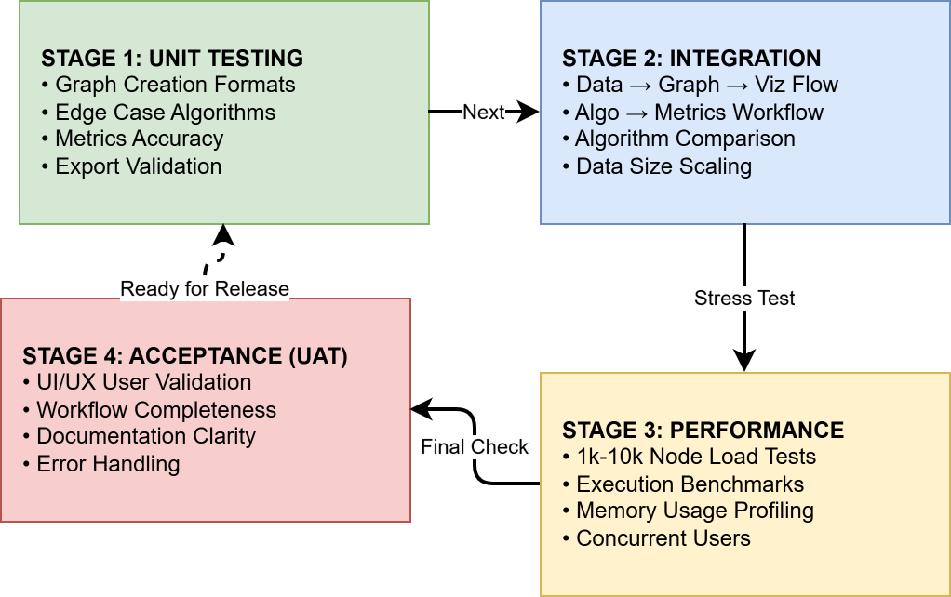
Figure 8.1 Testing flow Diagram

8.2 Risk Assessment
Risk | Probability | Impact | Mitigation | Contingency
Large Graph Performance Degradation | Medium | High | Graph size limits, optimization | Batch processing option
Algorithm Convergence Failure | Low | Medium | Timeout handling, error recovery | Fallback algorithm
Data Privacy Concerns | Medium | High | Local processing, no transmission | Data encryption option
Dependency Conflicts | Low | Medium | Version pinning, Docker | Alternative package versions
Browser Compatibility Issues | Low | Low | Cross-browser testing | Compatibility guide

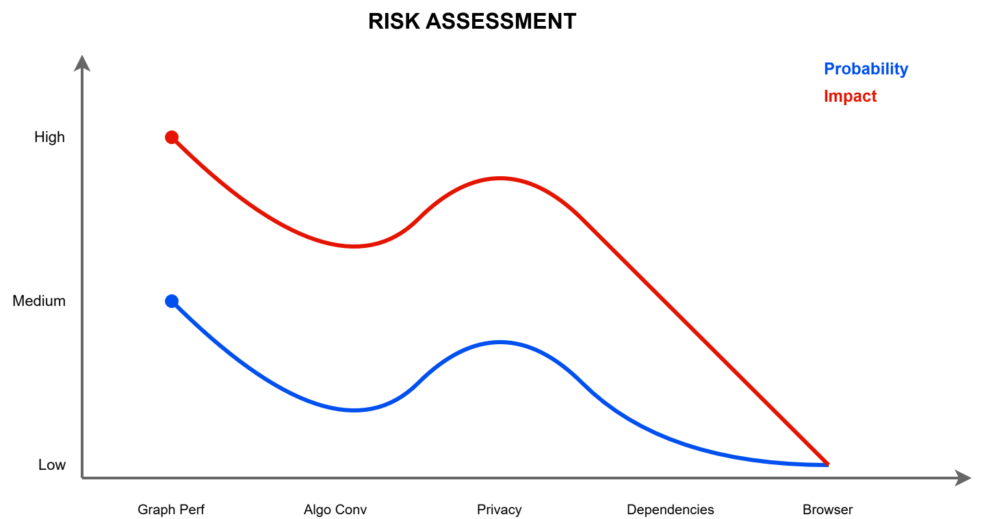
Figure 8.2 Risk Assessment

9. GLOSSARY
Term | Definition
Community | A subset of nodes with higher internal connectivity than external
Modularity | Metric measuring strength of community division (0-1 scale)
Betweenness | Centrality measure indicating how often a node bridges others
Clustering Coefficient | Measure of local clustering tendency in a network
Conductance | Quality metric for community isolation
Coverage | Proportion of edges within detected communities
Performance | Accuracy of community partition compared to ideal
Diameter | Longest shortest path between any two nodes
Density | Ratio of actual edges to possible edges
Assortativity | Tendency of similar nodes to connect
igraph | R package for network analysis and visualization
visNetwork | R package for interactive network visualization
Shiny | R framework for building interactive web applications

APPENDIX: ALGORITHM SPECIFICATIONS
A.1 Louvain Method
Objective: Maximize modularity through hierarchical optimization
Algorithm Steps:
- Each node assigned to its own community
- For each node, calculate modularity gain from moving to neighbor communities
- Move node to community with maximum gain
- Repeat until convergence
- Aggregate communities and repeat
Complexity: O(nlogn)
Best For: Large networks, modularity maximization
Parameters: None (deterministic)
A.2 Walktrap Algorithm
Objective: Find communities using random walk distances
Algorithm Steps:
- Compute random walk transition matrix
- Calculate distances between nodes based on random walks
- Use hierarchical clustering on distances
- Cut dendrogram to form communities
Complexity: O(mn²)
Best For: Networks with clear community structure
Parameters: Number of steps (default: 4)
A.3 Edge Betweenness
Objective: Iteratively remove high-betweenness edges
Algorithm Steps:
- Calculate betweenness for all edges
- Remove edge with highest betweenness
- Recalculate betweenness
- Repeat until desired number of communities
Complexity: O(m²n)
Best For: Small to medium networks, hierarchical structure
Parameters: None (deterministic)
A.4 Label Propagation
Objective: Propagate labels through network
Algorithm Steps:
- Assign unique label to each node
- For each node, adopt most frequent label among neighbors
- Repeat until convergence
- Nodes with same label form communities
Complexity: O(m+n)
Best For: Fast detection in large networks
Parameters: None (stochastic, may vary)
A.5 Fast Greedy
Objective: Greedy modularity optimization
Algorithm Steps:
- Start with each node as separate community
- Merge pair of communities with maximum modularity gain
- Repeat until single community
- Select partition with maximum modularity
Complexity: O(mdlogn)
Best For: Sparse networks, speed-focused detection
Parameters: None (deterministic)
A.6 Infomap
Objective: Minimize information flow description length
Algorithm Steps:
- Model information flow as random walk
- Find partition minimizing description length
- Use simulated annealing for optimization
- Nodes in same partition form communities
Complexity: O(m)
Best For: Flow-based communities, directed networks
Parameters: None (stochastic, may vary)

